

SOP – 016

PROCEDURE FOR
QUANTSTUDIO REAL-TIME PCR

TABLE OF CONTENTS

TABLE OF CONTENTS 2
APPROVAL AUTHORITY 3
RECORD OF AMENDMENTS 4
DISTRIBUTION LIST 5
LIST OF ABBREVIATIONS 6
1. Objective 7
2. Scope 7
3. Responsibilities 7
4. Principle 7
5. Parts of the instrument 8
6. Required Equipment’s & Reagents 8
7. Environment & Safety Control 8
8. Calibration Procedure 9
9. Equipment Record 12
10. Quality Control Procedure 13
11. Procedure & Method 13
12. Maintenance 18
13. Backup and Restore 19
14. Troubleshooting 19
15. Result Examination 19
16. References 20

APPROVAL AUTHORITY

Prepared by: | Head of Department | Dr. Sadiya Shahnaz  Name | Date: 14/11/2024

Signature
Reviewed & Approved by: | Laboratory Head | Dr. Abdul Aleem  Name | Date: 14/11/2024

Signature
Issued by: | BME Manager | Pallavi Elisetty  Name | Date: 14/11/2024

Signature

RECORD OF AMENDMENTS

S. No. | Ver. No. | Ver. Date | Rev. No. | Rev. Date | Description of Changes

Document Copy No. | Name / Designation of the holder of the document copy | Type of Copy | Version No. | Revision No.
01/10 | Managing Director | Controlled Copy | 01 | 00
02/10
03/10
04/10
05/10
06/10
07/10
08/10
09/10
10/10

DISTRIBUTION LIST

LIST OF ABBREVIATIONS
S. No. | Abbreviations | Expansion
1 | °C | Degree Centigrade
2 | HEPA | High Efficiency Particulate Air
3 | HOD | Head of Department
4 | LAF | Laminar Air Flow
5 | MSP | Management System Procedure
6 | N/A | Not Applicable/Available
 | PCR | Polymerase Chain Reaction
7 | QC | Quality Control
8 | QM | Quality Manager
9 | RNaseZap | Ribonuclease Zap
10 | SDA | Sabouraud Dextrose Agar
11 | SOP | Standard Operating Procedure
12 | TDPL | TRUSTlab Diagnostics Private Limited
13 | ULPA | Ultra-Low Particulate Air

- Objective
The purpose of this SOP is to provide guidelines for operating and maintaining the QuantStudio 5 Real-Time PCR instrument in the Molecular Biology Department, to ensure safe and proper usage.
- Scope
This procedure applies to all staff of the Molecular Biology Department.
- Responsibilities
  - It is the responsibility of the technicians of the Molecular Biology Department to comply with this SOP.
  - HOD shall ensure implementation.
  - The Quality Manager is responsible for monitoring, reviewing and ensuring compliance with this procedure.
  - All other TRUSTlab staff that may be involved in this process (including contract personnel) will be responsible for complying with this procedure.
- Principle
The QuantStudio™ 5 Real-Time PCR Instrument uses fluorescence-based polymerase chain reaction (PCR) reagents to perform:
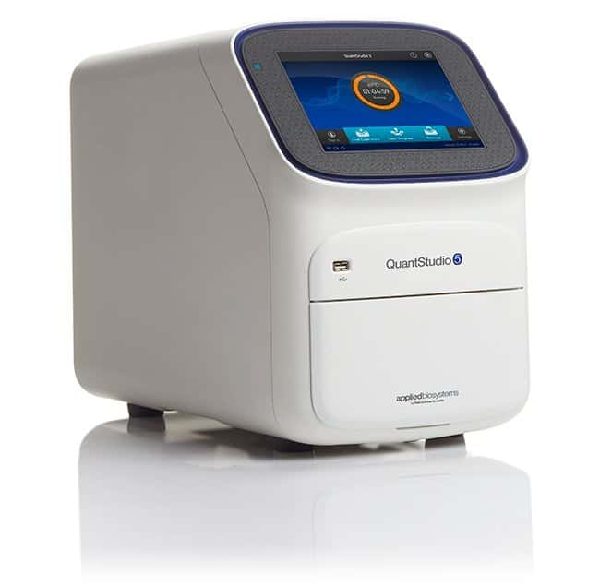
      - Quantitative detection of target nucleic acid sequences (targets).
      - Qualitative detection of targets (endpoint analysis, genotyping, and presence/absence)
      - The instrument is configured with a 96-well 0.2-mL fixed block (6 color de-coupled).
      - To run experiments using HID assays, the instrument must be integrated with the HID Real-Time PCR Analysis.
- Parts of the instrument
      - Touchscreen – Controls the instrument.
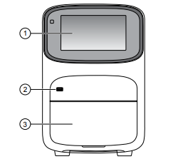
      - USB port – For connection to an external network drive or external data storage device.
      - Instrument drawer – Contains sample plate.
The instrument includes three additional USB ports on the back of the instrument.
Note: The instrument recognizes only one external storage device at a time for data transfer.
- Required Equipment’s & Reagents
      - QuantStudio™ 5 machine
      - Pipettors, 100-µL and 200-µL (with pipette tips
      - 70% ethanol
      - Tissue
      - Optical clear adhesive film for PCR
      - Safety glasses
      - Powder-free gloves
      - Deionized water
      - Region of Interest (ROI) and Background Plates, 96-Well 0.2-mL (2 plates)
      - QuantStudio™ 3/5 10-Dye Spectral Calibration Kit, 96-Well 0.2-mL (contains all 3 spectral calibration plates listed below)
      - QuantStudio™ 3/5 Spectral Calibration Plate 1, 96-Well 0.2-mL
      - QuantStudio™ 3/5 Spectral Calibration Plate 2, 96-Well 0.2-mL
      - QuantStudio™ 3/5 Spectral Calibration Plate 3, 96-Well 0.2-ml
- Environment & Safety Control
CAUTION! | Indicates a potentially hazardous situation that, if not avoided, may result in minor or moderate injury. It may also be used to alert against unsafe practices
WARNING! | Indicates a potentially hazardous situation that, if not avoided, could result in death or serious injury.
DANGER! | Indicates an imminently hazardous situation that, if not avoided, will result in death or serious injury.

Chemical Safety:  WARNING! GENERAL CHEMICAL HANDLING. To minimize hazards, ensure laboratory personnel read and practice the general safety guidelines for chemical usage, storage, and waste provided below, and consult the relevant SDS for specific precautions and instructions. | Minimize contact with chemicals.  Wear appropriate personal protective equipment when handling chemicals (for example, safety glasses, gloves, or protective clothing).  Minimize the inhalation of chemicals. Do not leave chemical containers open. Use only with adequate ventilation (for example, fume hood).  Check regularly for chemical leaks or spills. If a leak or spill occurs, follow the manufacturer's cleanup procedures as recommended in the SDS.  Handle chemical waste in a fume hood.  Ensure use of primary and secondary waste containers
Biological hazard safety:  WARNING! Potential Biohazard. Depending on the samples used on this instrument, the surface may be considered a biohazard. Use appropriate decontamination methods when working with biohazards. | Biological samples such as tissues, body fluids, infectious agents, and blood of humans and other animals have the potential to transmit infectious diseases.  All work should be conducted in properly equipped facilities using the appropriate safety equipment (for example, physical containment devices).  Safety equipment also may include items for personal protection, such as gloves, coats, gowns, shoe covers, boots, respirators, face shields, safety glasses, or goggles.  Individuals should be trained according to applicable regulatory requirements before working with potentially biohazardous materials
- Calibration Procedure
  - The instrument is factory-calibrated and does not require calibration at installation. To ensure optimal performance, perform calibrations at the recommended frequency.
  - Set the calibration frequency for the instrument:
Touch setting > Maintenance and Service > Calibrations>History and Reminders > Edit > Exp interval field
Calibration | Recommended frequency
ROI/Uniformity | • Every two years (recommended)  • Always perform new background and dye calibrations after an ROI/uniformity calibration. Note: Performing an ROI/uniformity calibration invalidates all other calibrations.
Background | • Every two years (recommended)  • Background calibration can also be performed, as needed: – To check for contamination (depends on usage and laboratory conditions). – To obtain the most accurate data for the removal of background fluorescence.  Note: Performing a background calibration does not invalidate any other calibration.
Dye | • Every two years (recommended)  • During a dye calibration, only the dyes on the given spectral calibration plate are calibrated. Note: Performing a dye calibration for a given dye plate does not invalidate any other calibration.
RNase P instrument verification | • After performing instrument calibrations  • As needed to confirm instrument performance
      - Note: Calibration is recommended with all Spectral Dye Calibration Plates even if all are not used.
      - Note: Do not discard the packaging for the calibration plates. Each calibration plate can be used up to 3 times if the plate is:
        - Stored in its packing sleeve at –15 to –25°C.
        - Used within 6 months after opening.
        - Used before the plate expiry date.
Perform an ROI/uniformity calibration.
You are automatically prompted to perform background calibration.

Perform a background calibration.
Perform any time that ROI/uniformity calibrations are current.

Perform system dye calibrations.
Perform any time that ROI/uniformity and background calibrations are current.
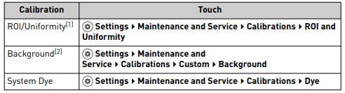
Instrument Settings
      - Perform an ROI/uniformity calibration:
Thaw, vortex, and centrifuge a calibration plate
(Thaw each plate for 30 minutes, Use each plate within 2 hours of thawing)

Remove the calibration plate from the freezer, then thaw the plate in its packaging.

Keep plates protected from light until you perform the calibration.

wear gloves, remove the calibration plate from its packaging and retain the packaging. (Do not remove the optical film.)

Vortex the plate for 5 seconds, then centrifuge at 750 to 1,000 × g for 2 minutes.

confirm that the liquid in each well is at the bottom of the well and free of bubbles. If it is not, centrifuge the plate again.

In the instrument home screen, set the calibration as shown in above table (ROI/Uniformity)

Load the plate into the instrument, touch start.

When the run is complete and the screen displays Calibration Complete, touch View Results to check the calibration status
Calibration status | Action
Passed | Touch Next to proceed to the next required calibration.
Failed | See “Troubleshoot calibration failure “

Unload the plate from the instrument& return the plate to its original packaging.
      - Perform a background calibration:
Whenever possible, use a background plates “Parts and materials “. These plates contain a buffer that accurately simulates the reagents used for PCR, and, therefore, produces high-quality calibration data.
Place the plate in the instrument and set the background calibration setup as shown in the earlier mentioned Settings table.
      - Perform system dye calibrations.
Follow the same procedure of ROI/uniformity calibration till centrifuge after that,

In the instrument home screen, set the dye calibration setup (system Dye) as shown in the above table.
Touch the custom dye to calibrate.

Enter the calibration temperature (Optional) Touch Reagents, then enter reagent information & Touch Start

When the run is complete and the screen displays Calibration Complete, touch View Results>Details.

Review the plot. Passing calibration results show uniform signals with peaks aligned with the dye wavelength.

Select an action depending on whether the custom dye calibration passed or failed.
Calibration status | Action
Passed | Touch Accept Results or Reject Results. Note: Accepting the results saves the calibration data to the instrument and overwrites existing data.
Failed | See “Troubleshoot calibration failure “

Unload the plate from the instrument.
- Equipment Record
      - Equipment Name: QuantStudio™ 5 Real-Time PCR
      - Manufacturer Name: Applied Biosystem by Thermo Fisher Scientific
      - Serial No & equipment ID:
          - 272528407-01 & TDPL/PR/CL-052
          - 252527162-02 & TDPL/PR/CL-053
      - Contact number application engineer:
      - Location: Central Lab, Begumpet Hyderabad.
- Quality Control Procedure
N/A.
- Procedure & Method
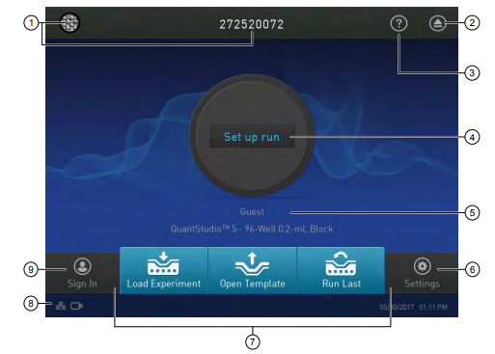
      - Parts of the home screen:
        - Avatar and Instrument name
        - Eject instrument drawer icon.
        - Help system icon
        - Status dial
        - Instrument profile name; instrument block type
        - Settings button
        - Access templates buttons
        - Connectivity icons
        - Sign In (or My Profile) button
      - Switch on the instrument:
Power on the instrument by pressing the switch on the rear panel.

If left unattended (for about two hours), the instrument automatically enters sleep mode (enabled by default) to conserve power.
      - Template creation:
        - Open QuantStudio 5 Interface in the system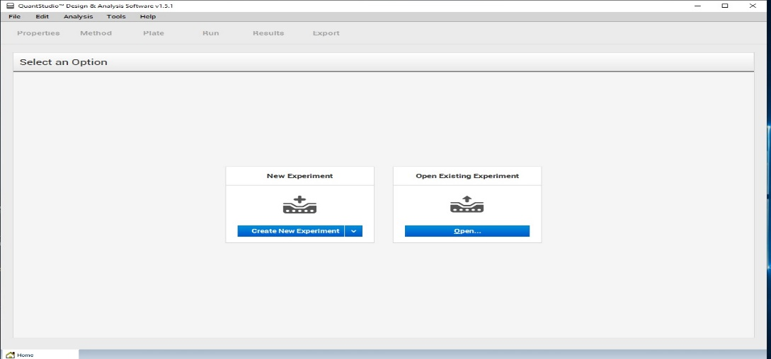
        - Create a new experiment:

Feed the details according to experiment properties.

Name of the experiment: e.g. covid-19-2025-02-15

Instrument type: QuantStudio$™$5 system

Block type: 96well 0.2-mL block

Experiment type: Standard curve

Chemistry: TaqMan® reagents

Run mode: Standard.
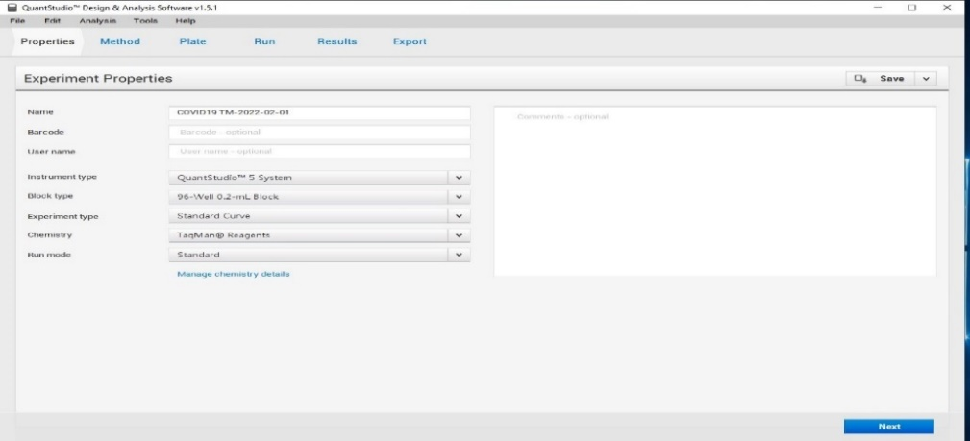

        - Experiment method:
          - Experiment cycles should be added as per the given kit inserts.
          - For e.g. volume, hold stage, PCR stage, PCR cycles & Data collection.
        - Plate setup:
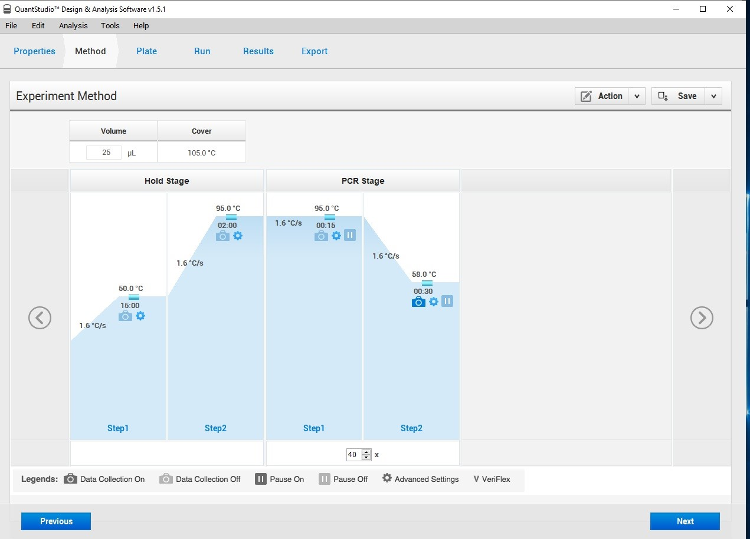
          - As per the kit insert enter all the details i.e. Targets, Quencher, Reporter dyes, passive reference, task, quantity & add the sample details.
          - Select all the genes for a particular sample, PC or standard & NTC.
          - For covid19 & HPV:
            - PC select task as a standard [S] except IC.
            - NTC select task as no temple [N] except IC.
          - For HIV, HBV HCV: PC select task as a standard [S] except IC and add particular test quantities as per the kit insert.
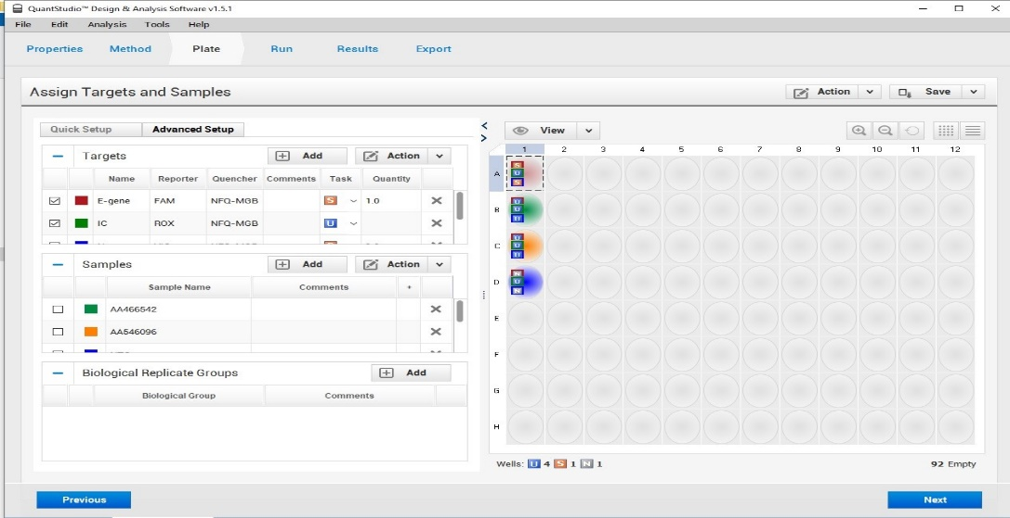
            - NTC select task as no temple [N] except IC.
        - Plate inserts in the machine:
After processing, the sample plate should be inserted as shown in the figure.
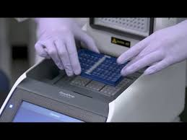

Click on the open drawer icon as it reflects in QuantStudio screen.
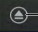

Insert the plate as shown in the fig. and close the drawer by press the icon.
      - Run Start:
Start the run by click on button “START RUN” and select the instrument ID and the save the file.
      - Analysis of Results:
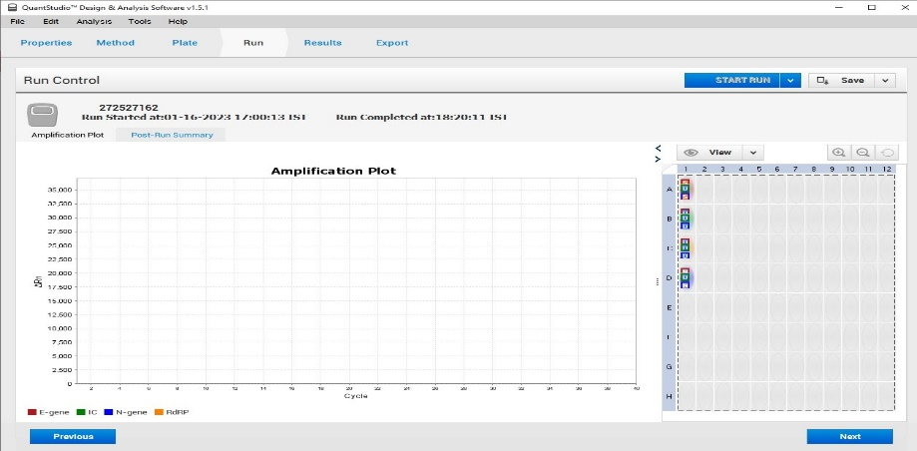
After the run has completed, click on analyze. Report as per the amplified graph/curve.
      - To Switch Off the Instrument:
Before switching off the instrument discard the inserted plate (96 well plate or 0.2ml strips)

Power Off using the power switch at the back of the instrument.

Power off the computer.
- Maintenance
Decontamination the sample block: | Perform this procedure to eliminate fluorescent contaminants from the instrument sample block. Contamination is generally evident in failed background falls results where one or more wells consistently exhibit abnormally high signals.  Power off and unplug the instrument, then allow it to cool for 15 minutes.  Pull the instrument drawer forward to expose the sample block.  Rinse the contaminated wells with deionized water.  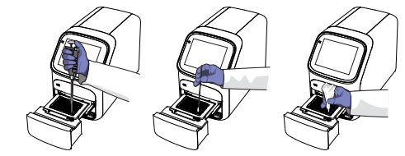  Clean the contaminated wells using a 95% ethanol solution
Rinse the sample block with deionized water: | Pipet a small volume of deionized water into each contaminated well.  In each well, pipet the water up and down several times to rinse the well.  Pipet the water to a waste beaker.  Use a cotton swab to scrub inside of each contaminated well.  Use a lint-free cloth to absorb the excess deionized water.
Clean the sample block with 95% ethanol: | Pipet a small volume of 95% ethanol solution into each contaminated well.  In each well, pipet the solution up and down several times to rinse the well.  Pipet the ethanol solution to a waste beaker.  Note: Always use deionized water to rinse wells after cleaning with ethanol solution.
- Backup and Restore
In the home screen: Touch Setting > Maintenance and Service > Backup/Restore.
To | Action
Backup | 1. Insert a USB into the front-panel USB port.  2. Touch Backup Instrument.  3. Touch USB.  4. Enter a backup file name, then touch Done.  5. Select which elements to backup or leave them all selected.  6. Touch Backup.
Restore (Administrator only) 1 | 1. Insert the USB that contains the backup file into the front-panel USB port.  2. Touch Restore a Backup.  3. Touch USB.  4. Select the backup file, then touch Restore
- Troubleshooting
Observation | Possible cause | Recommended action
Insufficient disk space message | Insufficient disk space to save a run | 1. In the home screen, touch Settings4Run History4Manage. 2. Delete or transfer experiments from the instrument.
The touchscreen is black | The instrument is in sleep mode. | Touch anywhere on the instrument touchscreen.
 | The instrument is not powered on. | If you touch the instrument touchscreen and it remains black, check if the instrument is powered on. The power switch is located on the rear panel of the instrument.
 |  | If the instrument does not power on, check that the instrument is properly plugged in.
 |  | If the instrument does not power on and the instrument is properly plugged in, contact Support.
- Result Examination
Based on amplified graph/curve as shown in Section 4.1.8 e (Analysis of results).
- References
Operating manual of QuantStudio 5 Applied Biosystem by ThermoFisher Scientific

